

**TERM 1 PRACTICAL EXAM – 2021 - 2022**

**COMPUTER SCIENCE PROJECT SYNOPSIS**

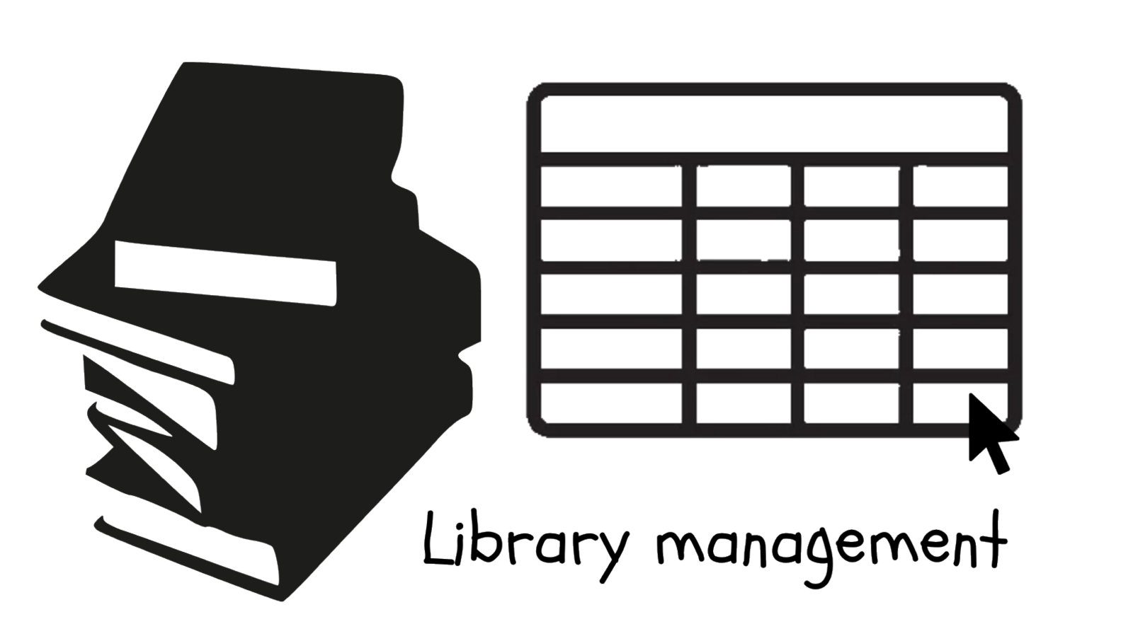

**BIANCAA. R**

**12B**

**7206**



**TERM 1 PRACTICAL EXAM – 2021 - 2022**

**COMPUTER SCIENCE PROJECT SYNOPSIS**



**AVANTHIKA. A**

**12B**

**7205**

**TITLE OF THE PROJECT**

Library Management System (For textbooks in our library)

**PROBLEM DEFINITION**

There are records in the library for all sorts of books that students take, but none are kept for the subject textbooks and reference books that teachers borrow.

**TEAM**

Biancaa. R , Avanthika.A

**PROJECT DETAILS**

Keep a record of the books taken by the teachers in a library using a database management system. Digitalization of the whole management process. Serial records of all purchased books (subject books in this case) in the library. Public access that enables users to search for a particular book using specific details (like author, publisher, edition, subject, etc.). Creation of a map of the library (a bird’s-eye view) that clearly specifies the available books and their locations. A system to check for availability of books and reserve books unavailable at that point of time. Generating QR codes that contain all necessary details of a borrowed book, to send reminders on when to return the book to the mail of the teacher.

**REASON FOR CHOOSING THE PROJECT**

Realising that it's a very difficult task to manage records in a library, we wanted to do something useful for the same. On talking with our librarian, we came to know about the unavailability of records regarding subject text books, reference books and question banks which teachers usually borrow. So a management system was decided to be made as a solution for this.

**OBJECTIVES**

* To make a management system to keep track of books with an user-friendly interface (GUI), using python
* To package the project files into a single setup file that can be installed and used on a computer

**SOFTWARE REQUIREMENTS**

* Python 3.6X or higher
* Any modern operating system (Windows * 7 or later, Linux, macOS)
* PyQt5 tools and PyQt5 designer to be installed
* Pyzbar, pyqrcode for generating, decoding qr code
* MySQL connector to establish connection between python and MySQL

**LIMITATIONS**

* The end product may not be as user-friendly as the fancy apps in playstore
* Continuous working of mysql server.
* Requirement of uninterrupted internet facility to send reminders to clients

**BIBLIOGRAPHY**

* Python basics, using python libraries and SQL connectivity - Sumita Arora Class 11, Sumita Arora Class 12 (Computer Science)
* Installing MySQL connector, setup

<https://dev.mysql.com/doc/connector-python/en/connector-python-installation.html>

* Installing PyQt5 tools and designer, setup and basics <https://realpython.com/qt-designer-python/>
* Installing Pyzbar, Pyqrcode, setup and basics

<https://pythonhosted.org/PyQRCode/>

https://pypi.org/project/pyzbar/

* PyQt5 tutorial, used as reference

<https://www.tutorialspoint.com/pyqt5/index.htm>

* Converting .ui file to .py

<https://www.tutorialexample.com/convert-qt-desiger-ui-file-to-python-script-file-py-pyqt-tutorial/>

* Packaging the project for installation

<https://packaging.python.org/tutorials/packaging-projects/>

<https://medium.com/@amimahloof/how-to-package-a-python-project-with-all-of-its-dependencies-for-offline-install-7eb240b27418>